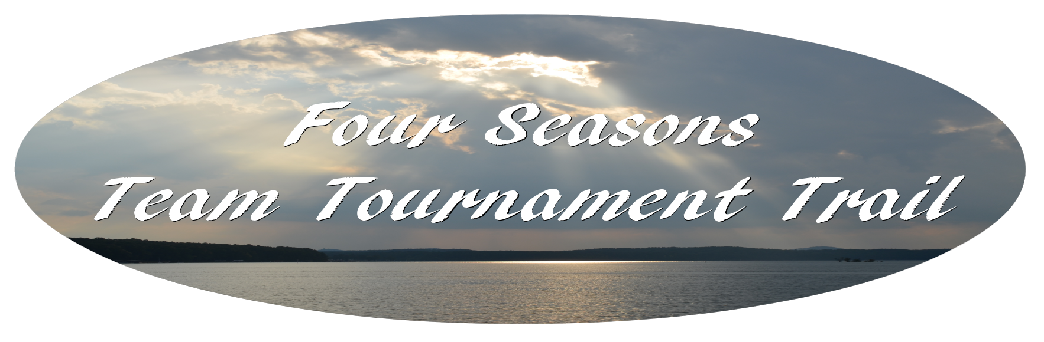
PARTICIPANT AGREEMENT, RELEASE AND ACKNOWLEDGEMENT OF RISK

In consideration of Bay Marine / The Dugout / Oakwood allowing me to participate in this tournament, I acknowledge and agree as follows:

- I have read and understand the description of the tournament and Official Rules of this tournament. I will obey all rules and understand that any violation may result in immediate disqualification without refund or my entry fee. I also understand that the tournament officials may reject my application for any reason and in that event will refund my entire entry fee.
- I understand and acknowledge that competitive fishing is a dangerous sport, the risks of which include, though not exclusively, drowning, collisions in the water, and injuries from hooks and other fishing paraphernalia. I voluntarily assume responsibility for these risks, identified and not identified, and all risk of injury or death or damage to myself or my property or to others, including spectators and their property arising from my participation in the tournament.
- I hereby release, discharge, and agree to hold harmless and indemnify, Bay Marine, Inc., The Dugout, Oakwood, their shareholders, officers, directors, agents and employees, the host, sponsors and tournament from any and all liability, claims, demands, actions or rights of action which are related to , arise out of or are in any way connected with my participation in this tournament, including specifically, but not limited to, the negligent acts or omissions of Bay Marine, Inc., The Dugout, Oakwood, their shareholders, officers, directors, agents and employees, the host, sponsors and tournament officials, and their partners, agents or employees and all other persons or entities associated with the tournament, for any injury, death, illness or disease, and other damage or loss to property suffered by myself or others. In signing this document, I acknowledge and agree that if anyone is hurt or property is damaged while I am engaged in this event, I will have no right to make claim or file a lawsuit against Bay Marine, Inc., The Dugout, Oakwood, their shareholders, officers, directors, agents and employees, the host, sponsors and tournament officials, and their partners, agents or employees and all other persons or entities associated with the tournament, even if they or any of them negligently caused the bodily injury or property damage.
- Any suit brought by me against Bay Marine, Inc., The Dugout or Oakwood as a result of my participation in this tournament will be brought in the state or county of Cobb, Georgia where the principal offices of Bay Marine, Inc. and The Dugout are located. Should it become necessary for Bay Marine, Inc., The Dugout, Oakwood, or someone on their behalf, to incur attorney's fees and costs to enforce this agreement, or any portion thereof, I agree to pay the reasonable costs and attorney's fees thereby expended, or for which liability is incurred.
- I have sufficient health, accident and liability insurance to cover my bodily injury or property damage incurred by myself or others as a result of my participation in this event. If I have no insurance, I represent that I am capable for paying for any and all such expenses and liabilities.
- I have no past or present medical or psychological condition that might affect my participation in the tournament in such a way as to cause harm to myself or others.
- I give Bay Marine, Inc., The Dugout and Oakwood permission to use my name and photograph for promotional purposes. I agree to submit to and accept the results of the polygraph test given at this location.

My signature below reflects that I have read the entire document, understand it completely, understand that it affects my legal rights, and agree to be bound by it's terms. References herein to “I”, “My”, “myself” and other first person shall include any child for whom I have signed.

Boater/Captain: ____________________________________________________________________________

Angler: ____________________________________________________________________________

Angler/Alternate: __________________________________________________________________________

